CHAPTER - 12

OUTPUT SCREENS

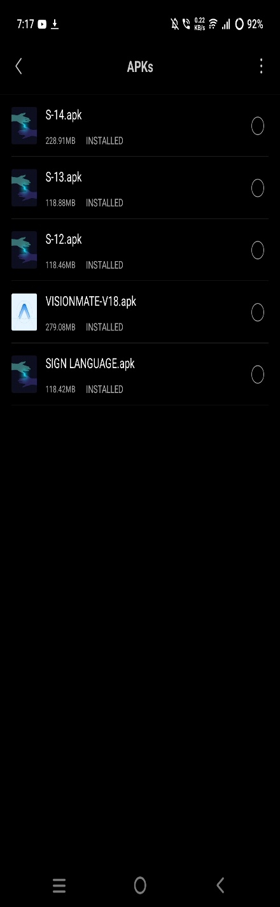
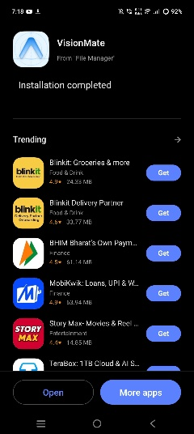
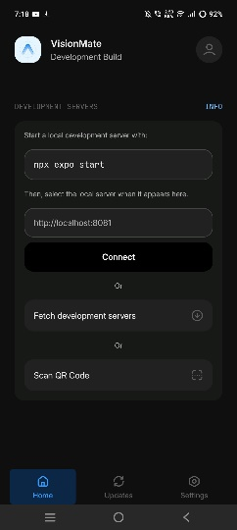
APK installation
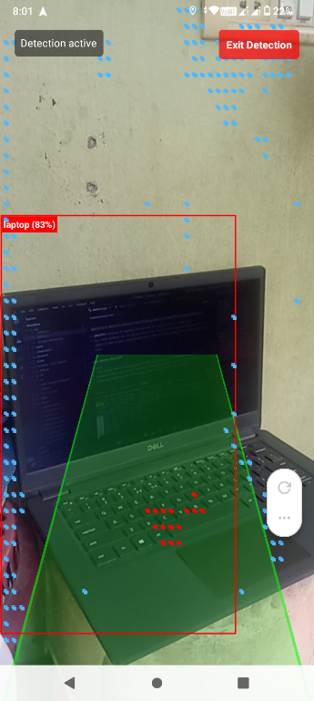
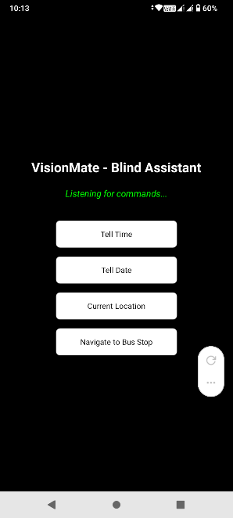
Obstacle Detection Mode interface
The user interface has some core functionality buttons to make it more user friendly for the blind user
User Interface

Detecting Indoor Objects

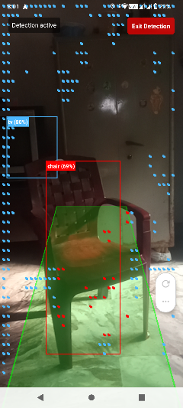
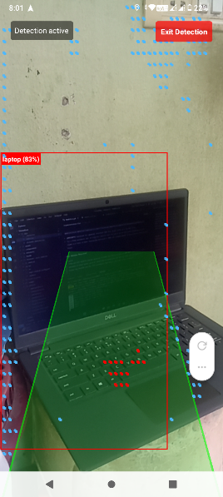
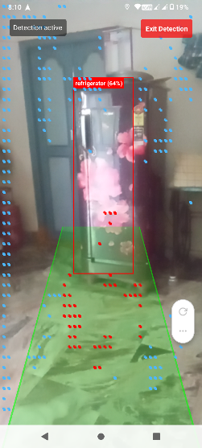

Detecting Obstacles on road

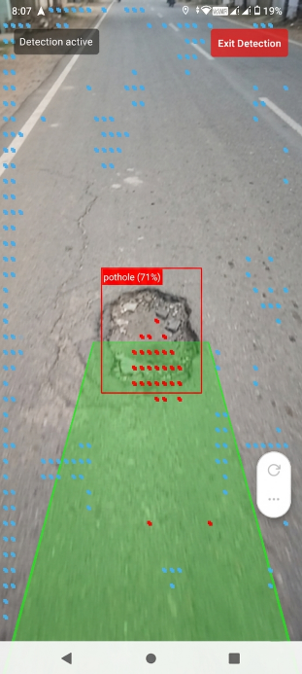
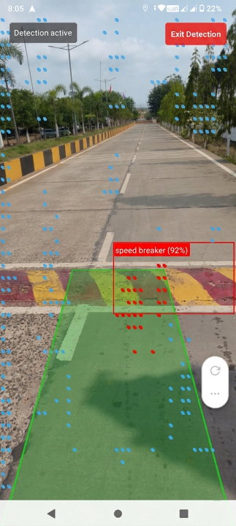

Opening Other apps

Opens the G-maps and
set destination in walking mode
Opens the YT-Music and
search for the song

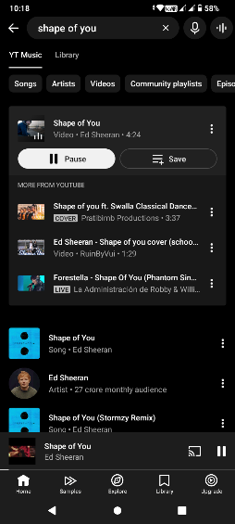
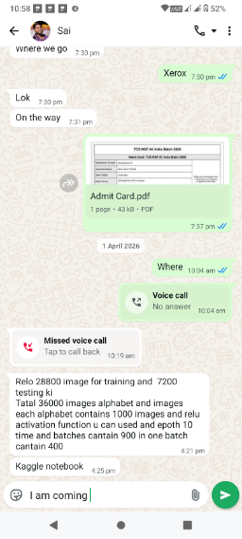
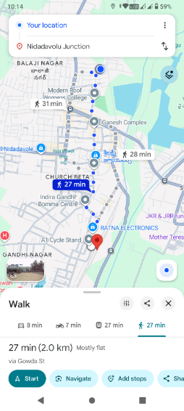
Opening YouTube Music
Text your Friend
Opening Gmap’s

Opens Whatsapp, search for the contact
And fill the message

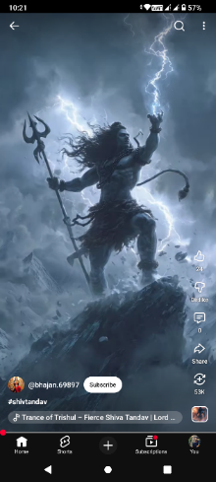
Opening YouTube
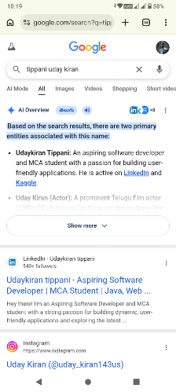
Browse The Internet

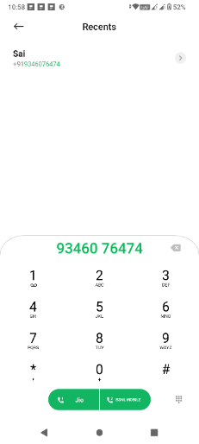

Opens the search engine
And search for the queries

Open Dialer With Contact
Opens YouTube and
directly plays the shorts

Opens dialer and
search the contact

